Lab 1 – Setting Up Flutter and Running Your First App
1. Objective
This lab helps students set up the Flutter environment and run their first Flutter application. Students will learn how to install tools, create a project, execute it on a device/emulator, and perform basic UI customization.
2. Requirements
Students must:
- Install Flutter SDK
- Configure IDE (Android Studio or VS Code)
- Create and run a Flutter app
- Customize the layout
- Submit screenshots as evidence
3. Guided Steps
Exercise 1 – Flutter Environment Setup
Goal: Install and verify Flutter tools.
Steps
- Install Flutter SDK.
- Add Flutter to PATH.
- Run:
flutter doctor
- Ensure all items are properly configured.
- Verify Flutter & Dart plugins in Android Studio.
Deliverables
- Screenshot of flutter doctor
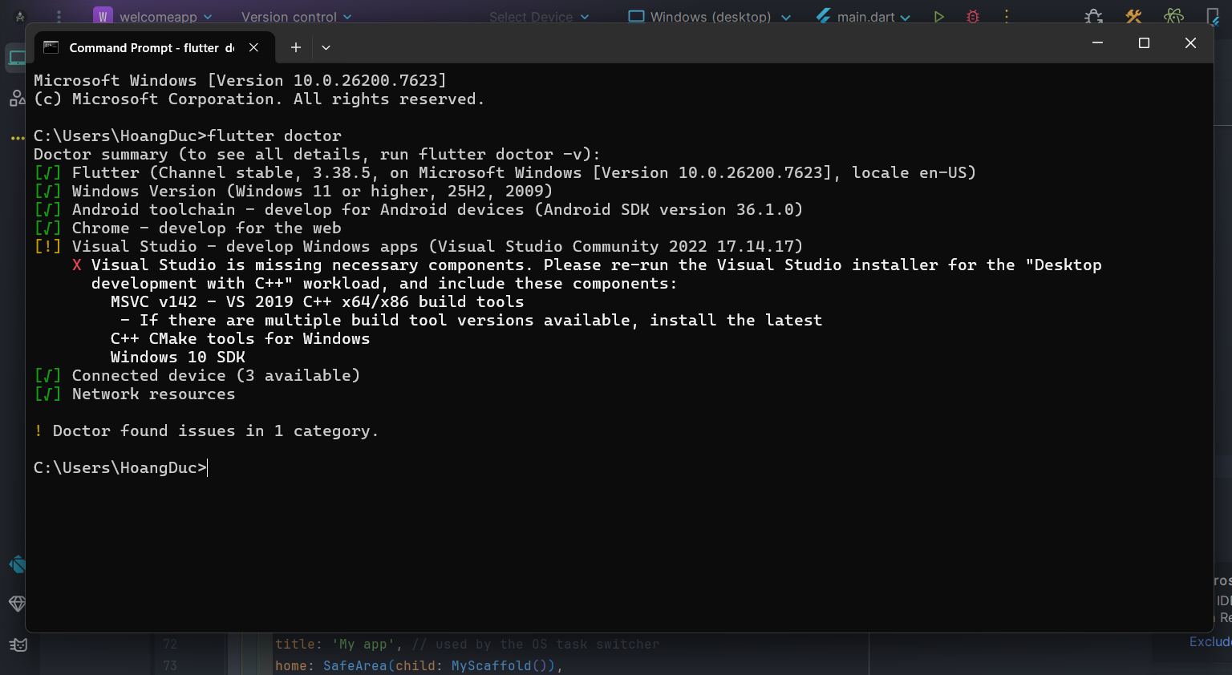
- Screenshot of Flutter/Dart plugin screen
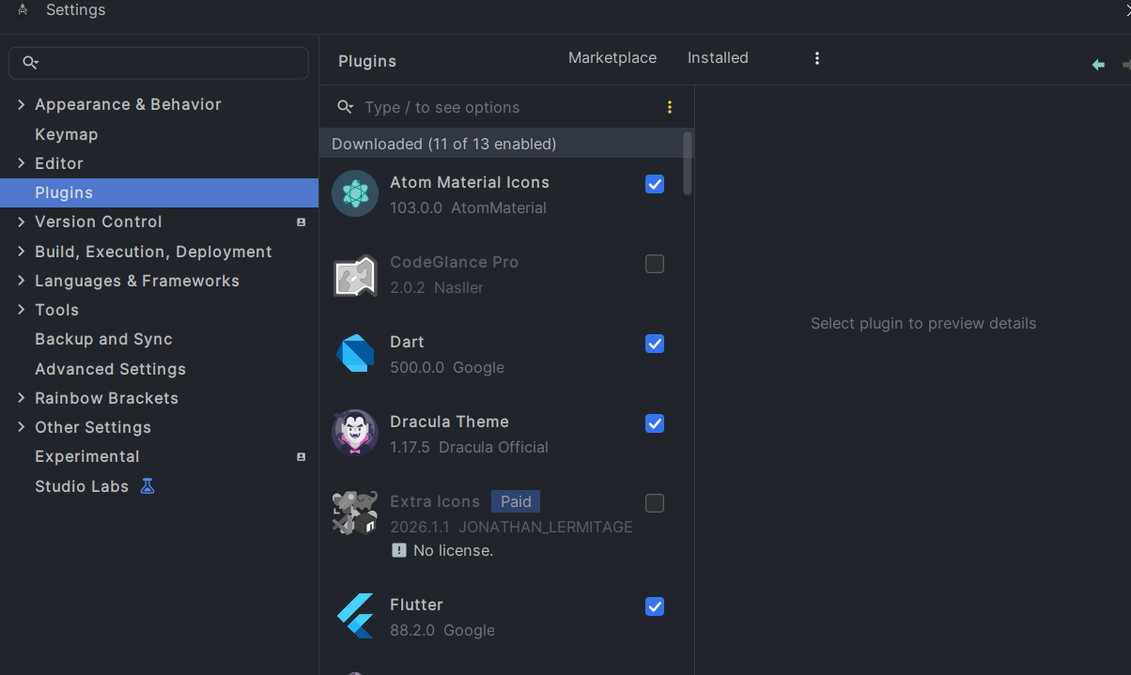
Exercise 2 – Create and Run Your First Flutter App
Goal: Learn how to create a Flutter project and run the default app.
Steps
- Open Android Studio → New Flutter Project
- Use project name: hello_flutter_lab1
- Explore key folders: lib/, android/, ios/, pubspec.yaml
- Start emulator or connect device
- Run the default counter app
- Modify the AppBar title in main.dart:
title: 'My First Flutter App',
- Use Hot Reload and observe changes
Deliverables
- Screenshot of project structure
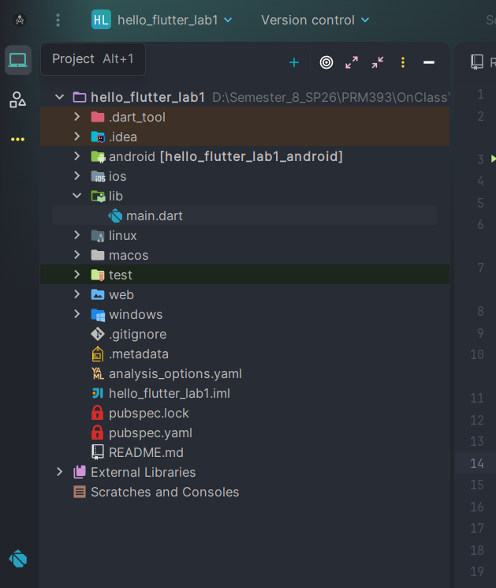
- Screenshot of running counter app
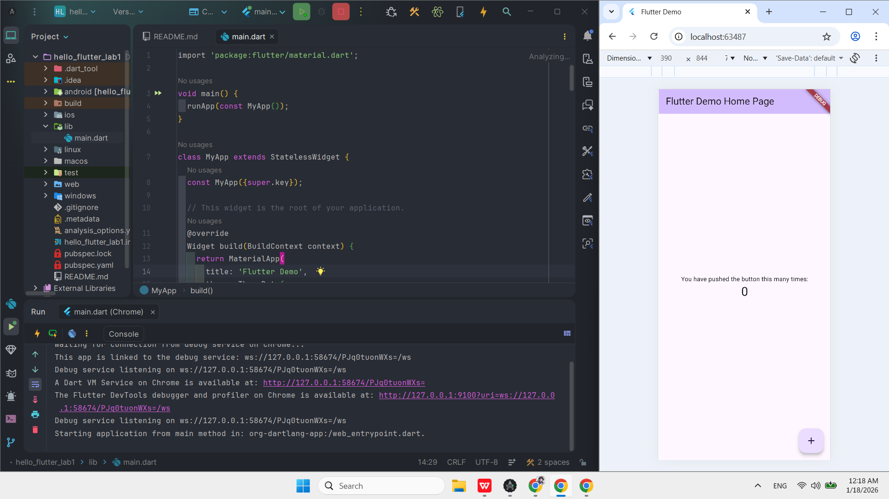
- Screenshot showing updated title via Hot Reload
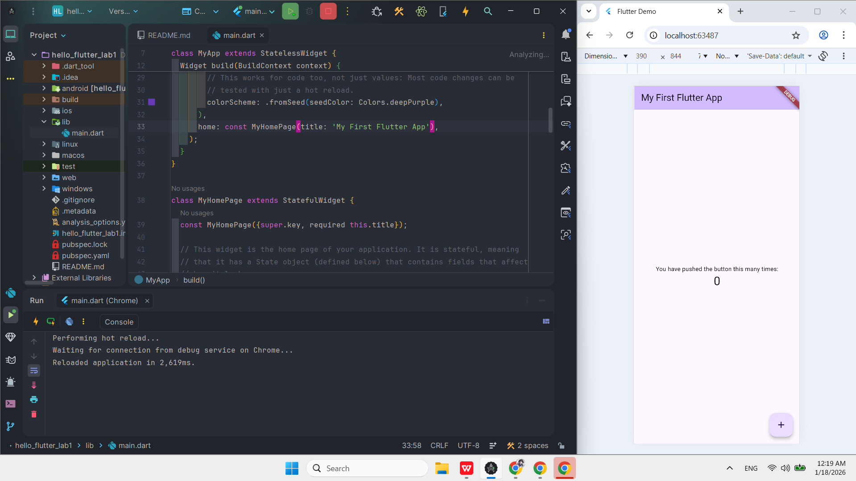

Exercise 3 – Customize Your First Flutter UI
Goal: Build a simple custom UI with widgets learned in class.
Steps
- Replace default code in main.dart with:
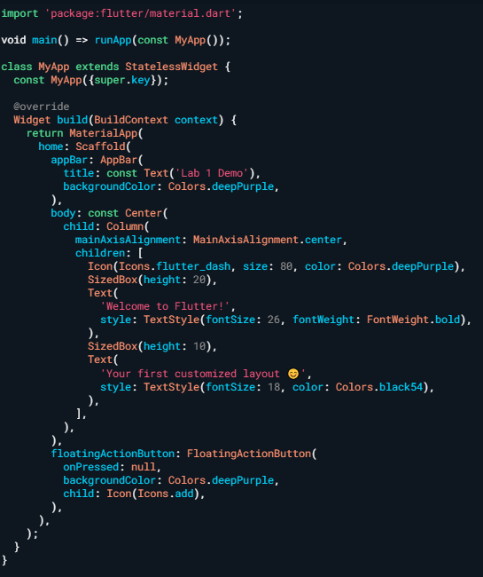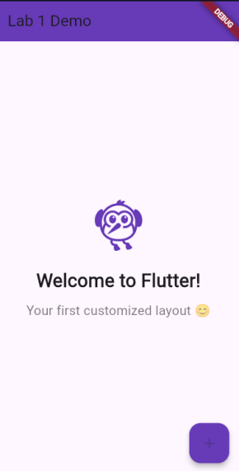
- Perform Hot Reload and verify UI updates.
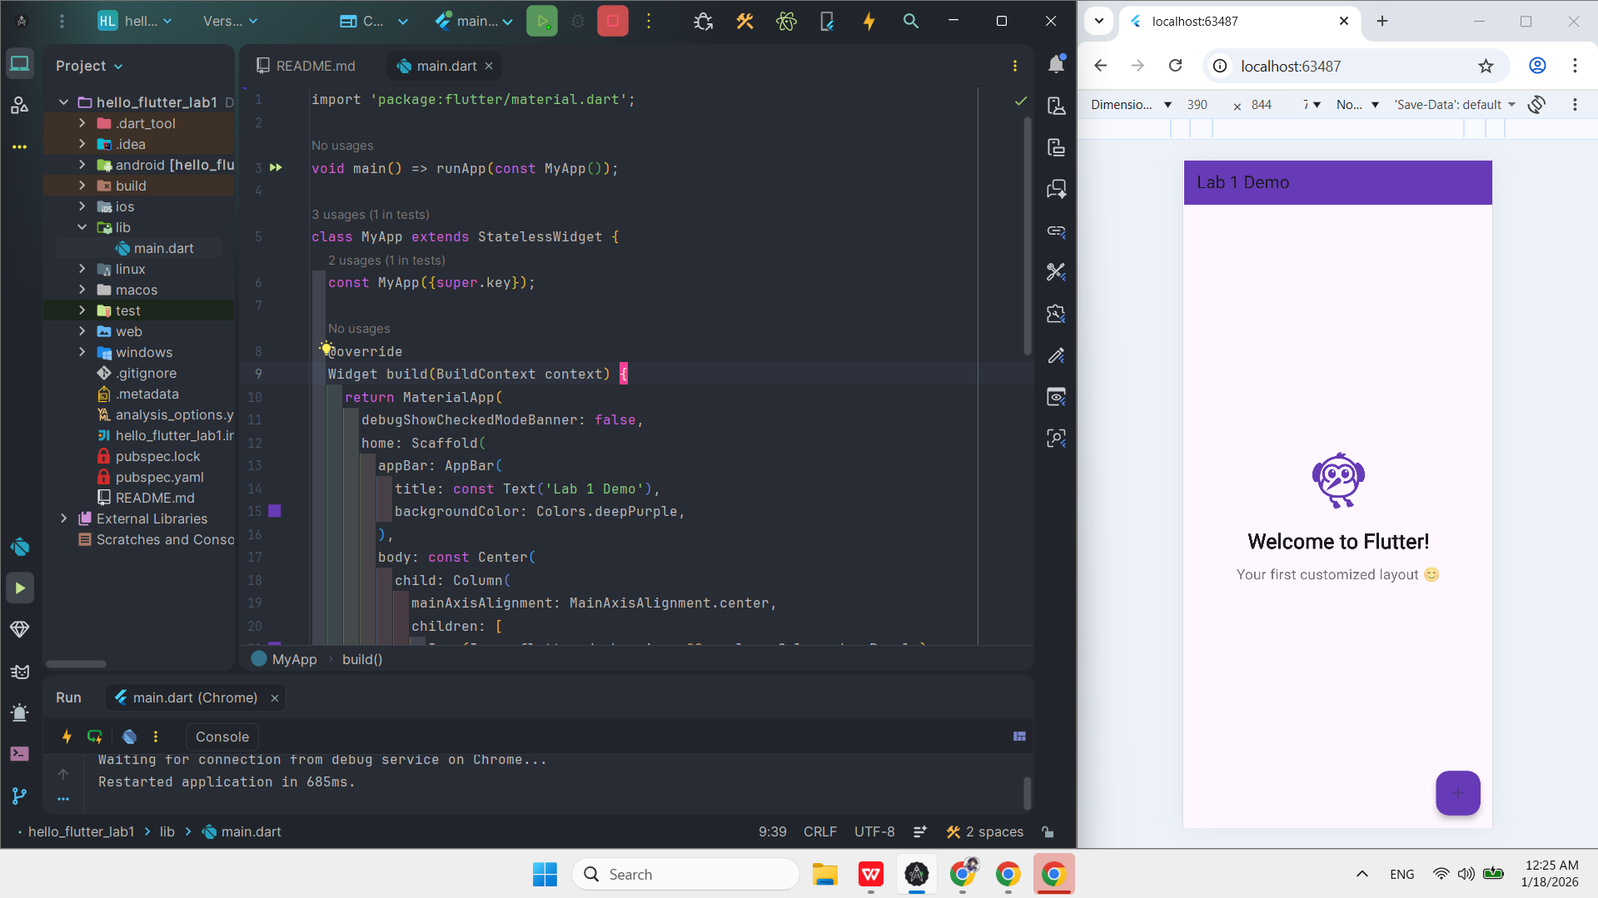
- Modify colors/text and reload again.
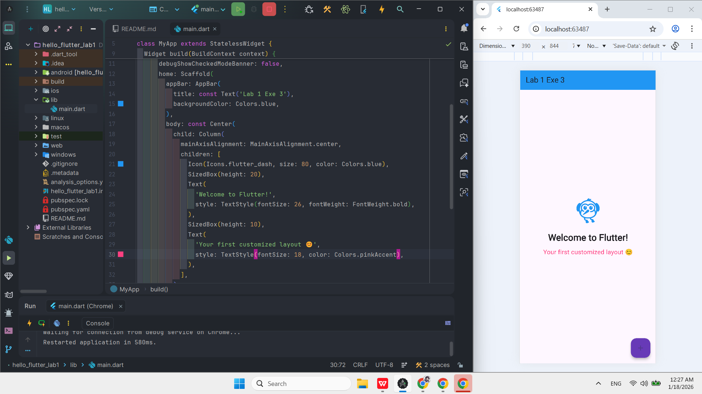
Exercise 4 – Reflection Questions
- What is the purpose of the flutter doctor command?
=> It checks your system to see if the Flutter SDK and all required tools are installed correctly. It tells you if anything is missing.
- What file acts as the entry point of a Flutter application?
=> The lib/main.dart file acts as the entry point where the application starts execution.
- Explain the difference between Hot Reload and Hot Restart.
=> Hot Reload: Quickly updates the UI and keeps the current app data (state).
Hot Restart: Restarts the entire app and resets all app data (state) to the beginning.
- How does runApp() build the widget tree?
=> It takes the root widget you provide and attaches it to the screen. It then builds all the child widgets under it to create the full UI tree.
- Describe how Flutter’s architecture enables cross-platform development.
=> Flutter uses its own graphics engine to draw every pixel on the screen. Because it doesn't rely on the phone's native UI components, it looks and works the same on Android, iOS, and Web.
4. Expected Results
- Successful setup of Flutter environment
- Ability to create and run Flutter projects
- Understanding of widgets, layout, and hot reload
- Complete screenshots for all required steps

5. Submission
- Zipped Flutter project folder or GitHub link
- All screenshots
- Written answers for reflection questions
import 'package:flutter/material.dart';
void main() {
runApp(const MyApp());
}
class MyApp extends StatelessWidget {
const MyApp({super.key});
@override
Widget build(BuildContext context) {
return MaterialApp(
home: Scaffold(
appBar: AppBar(
title: const Text("Lab 1 Demo"),
foregroundColor: Colors.black,
backgroundColor: Colors.purple,
),
body: const Center(
child: Column(
mainAxisAlignment: MainAxisAlignment.center,
children: [
Icon(Icons.flutter_dash, size: 80, color: Colors.purple),
SizedBox(height: 60),
Text(
"Welcome to flutter!",
style: TextStyle(fontSize: 24, fontWeight: FontWeight.bold),
),
SizedBox(height: 60),
Text(
"My first customized app :)",
style: TextStyle(
fontSize: 20,
fontWeight: FontWeight.bold,
color: Colors.purple,
),
),
],
),
),
floatingActionButton: FloatingActionButton(
onPressed: () => print("Hello World!"),
child: Icon(Icons.plus_one_sharp),
backgroundColor: Colors.purple,
),
),
debugShowCheckedModeBanner: false,
);
}
}

